**Conversation Log**

Below are some screenshots and annotation of the conversation between the chatbot and the user

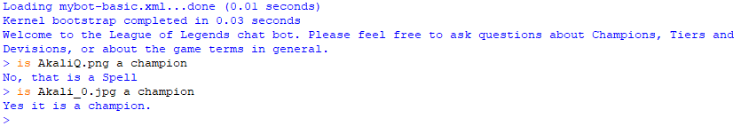

Here you can see the user asking if an image of a spell is a champion to which the chatbot replied with the correct answer by recognising what the image is off using the model which consist of 4 classes. The second time the user asks the same question, but this time uses the image of a champion which the bot recognises and replies yes.

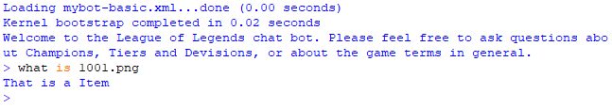

Here is another example of the bot identifying the image correctly.

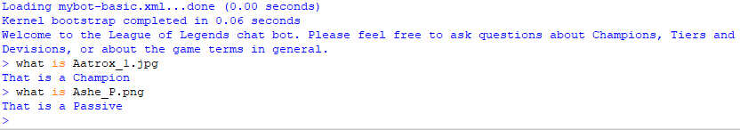

Here you can see similar question being asked where the user asks the bot what the image is off to which the chatbot is replying with the correct answer by identifying the image correctly.